**Project Title:** Router Configuration

**Objectives:**

* This project is to understand how to login into Router’s Admin interface
* This project is to learn how to setting up and customizing the setting of a Router
* This project is to provide knowledge of various functions of a Router

**Methodology:**

Step 1: First, I am checking the IP address of my Router using **ipconfig** command, here ‘Default Gateway’ is my home Router’s IP address.

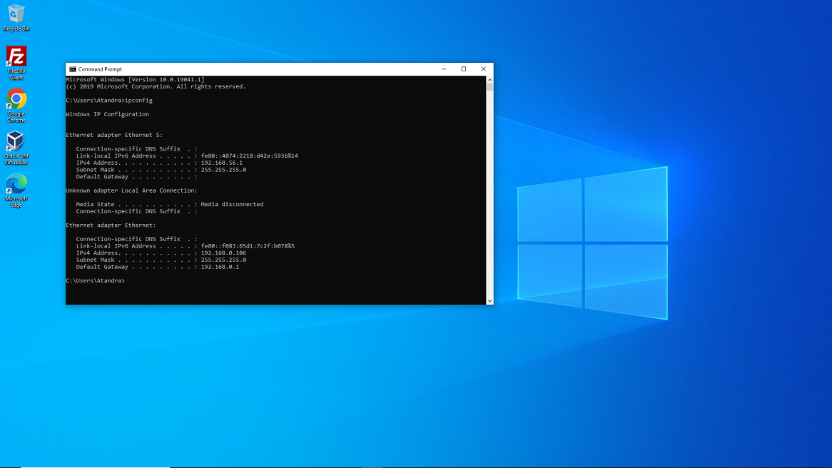

Step 2: Next I have searched my home Router’s IP address in web browser and I get an interface like this for logging into my Router’s Admin interface. Now here I have to put the password of my Admin credentials.

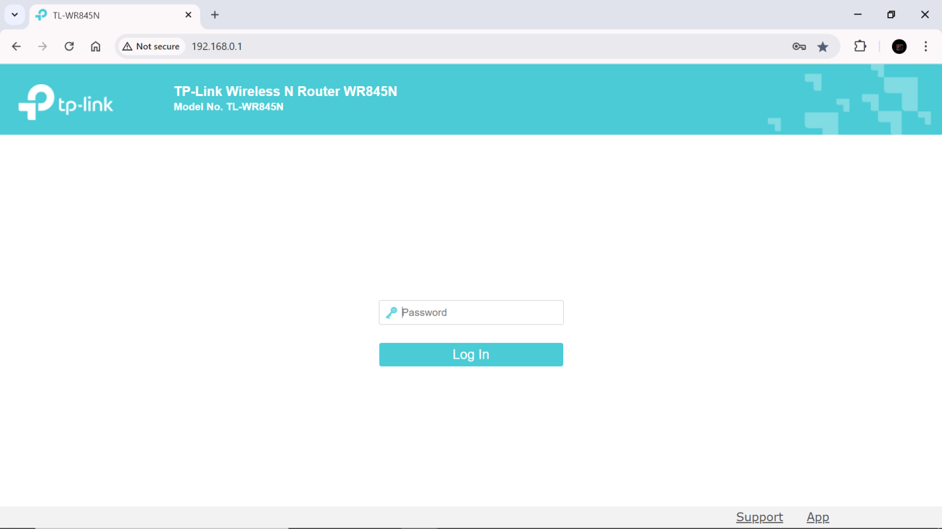

Step 3: Now I can configure the SSID (Service Set Identifier), which is the name of my WI-FI network that appears when searching for networks on a device. After change the setting I have to click on ‘save’

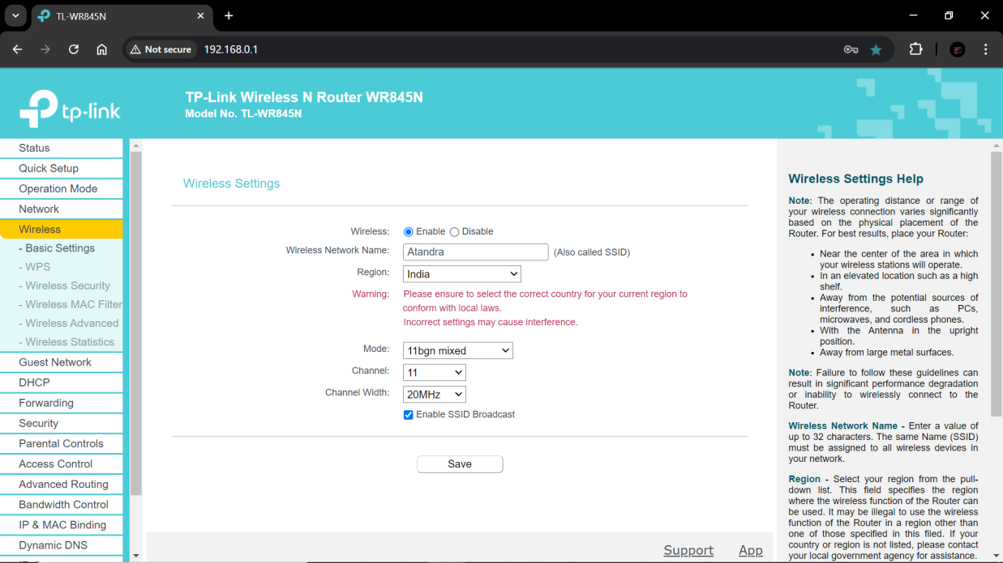

Step 4: Here I can set up or change the WI-FI password (using encryption standards like WPA2 or WPA3). After change the setting I have to click on ‘save’

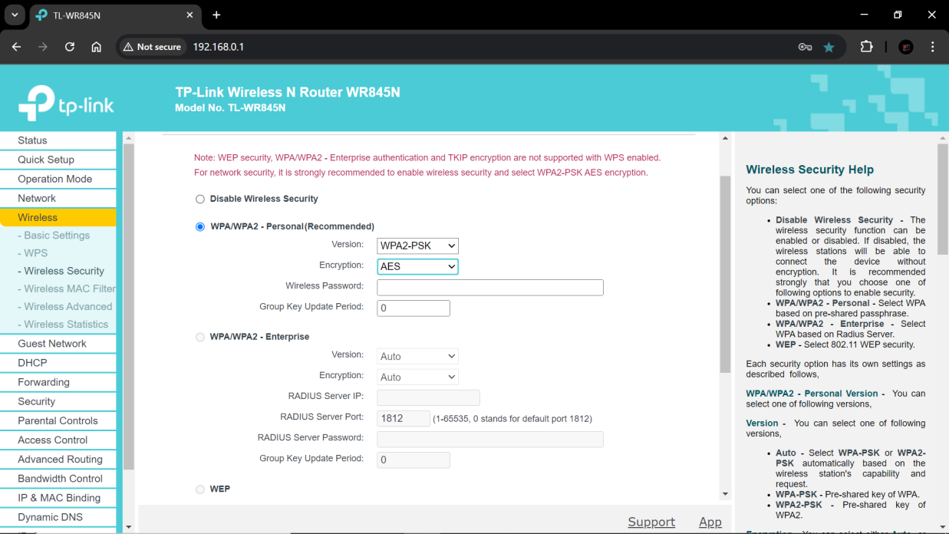

Step 5: Here I can configure DHCP (Dynamic Host Configuration Protocol). DHCP automatically assign IP addresses to devices on the network. I can enable or disable or customize the range of IP addresses the router will assign to devices. After change the setting I have to click on ‘save’

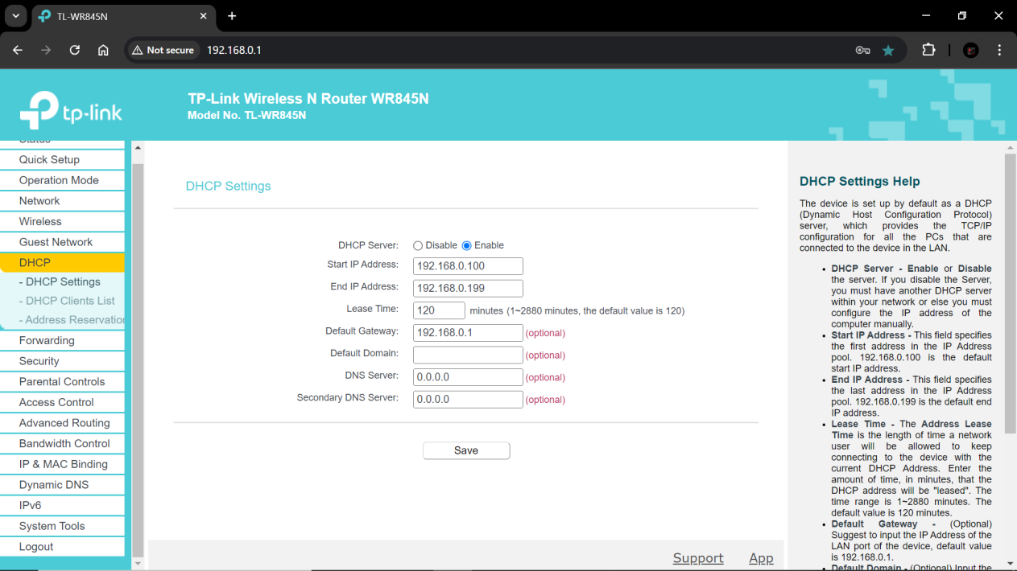

Step 6: Routers have a built-in firewall setting to block certain types of traffic to protect our network. I can enable or configure these settings for enhanced security. After change the setting I have to click on ‘save’

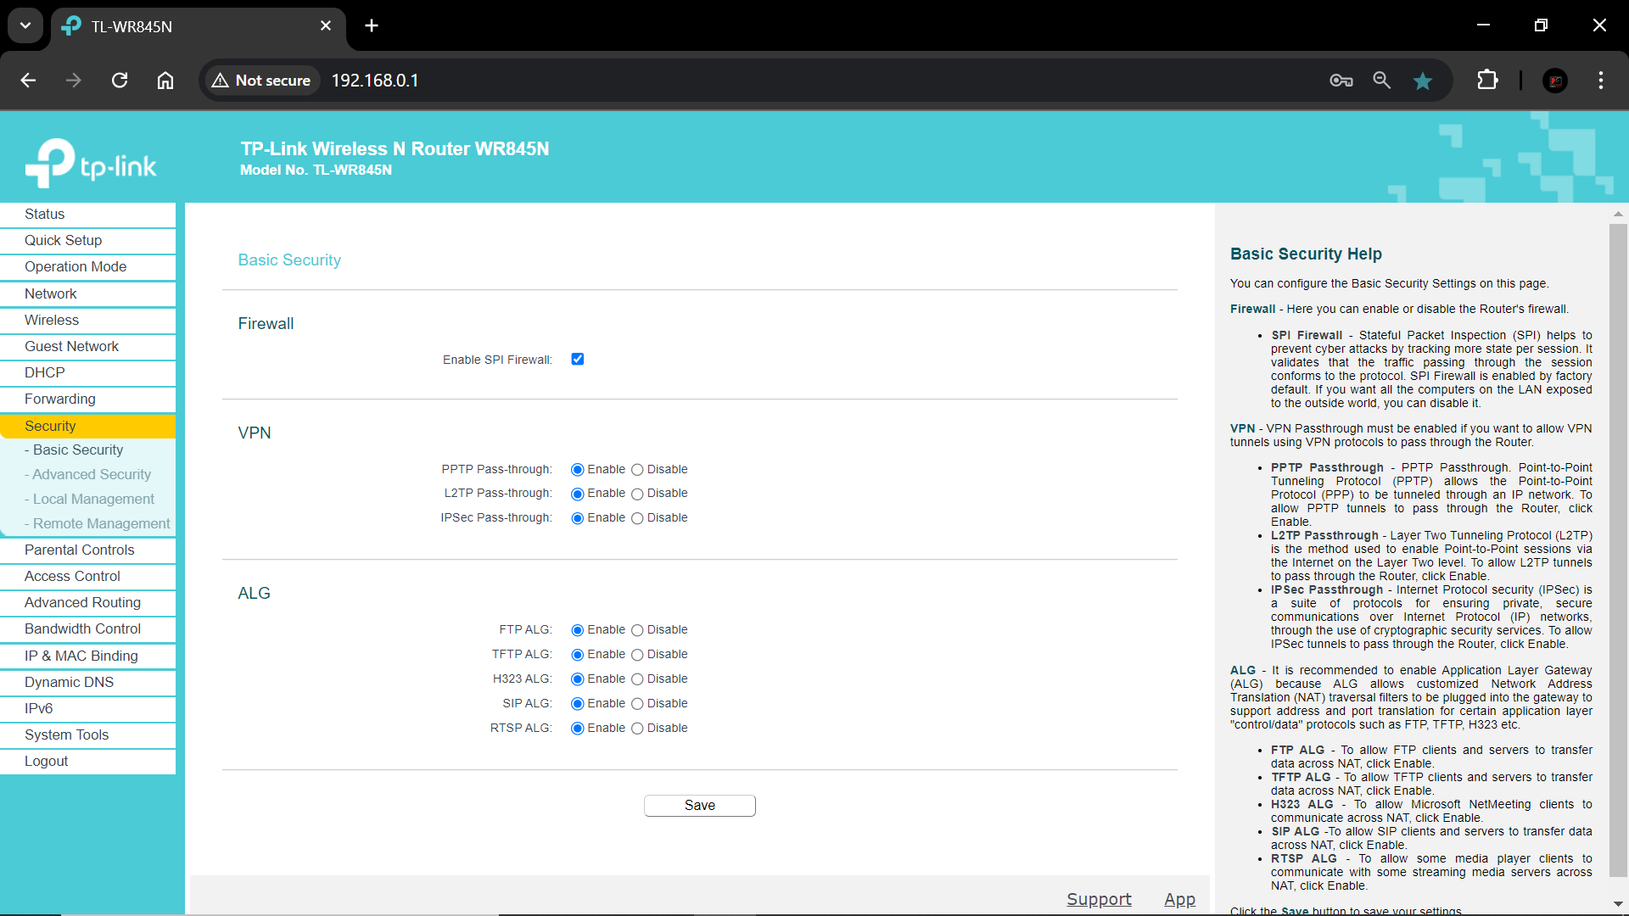

Step 7: Here I can check and install firmware updates to improved my Router performance, security and add new features.

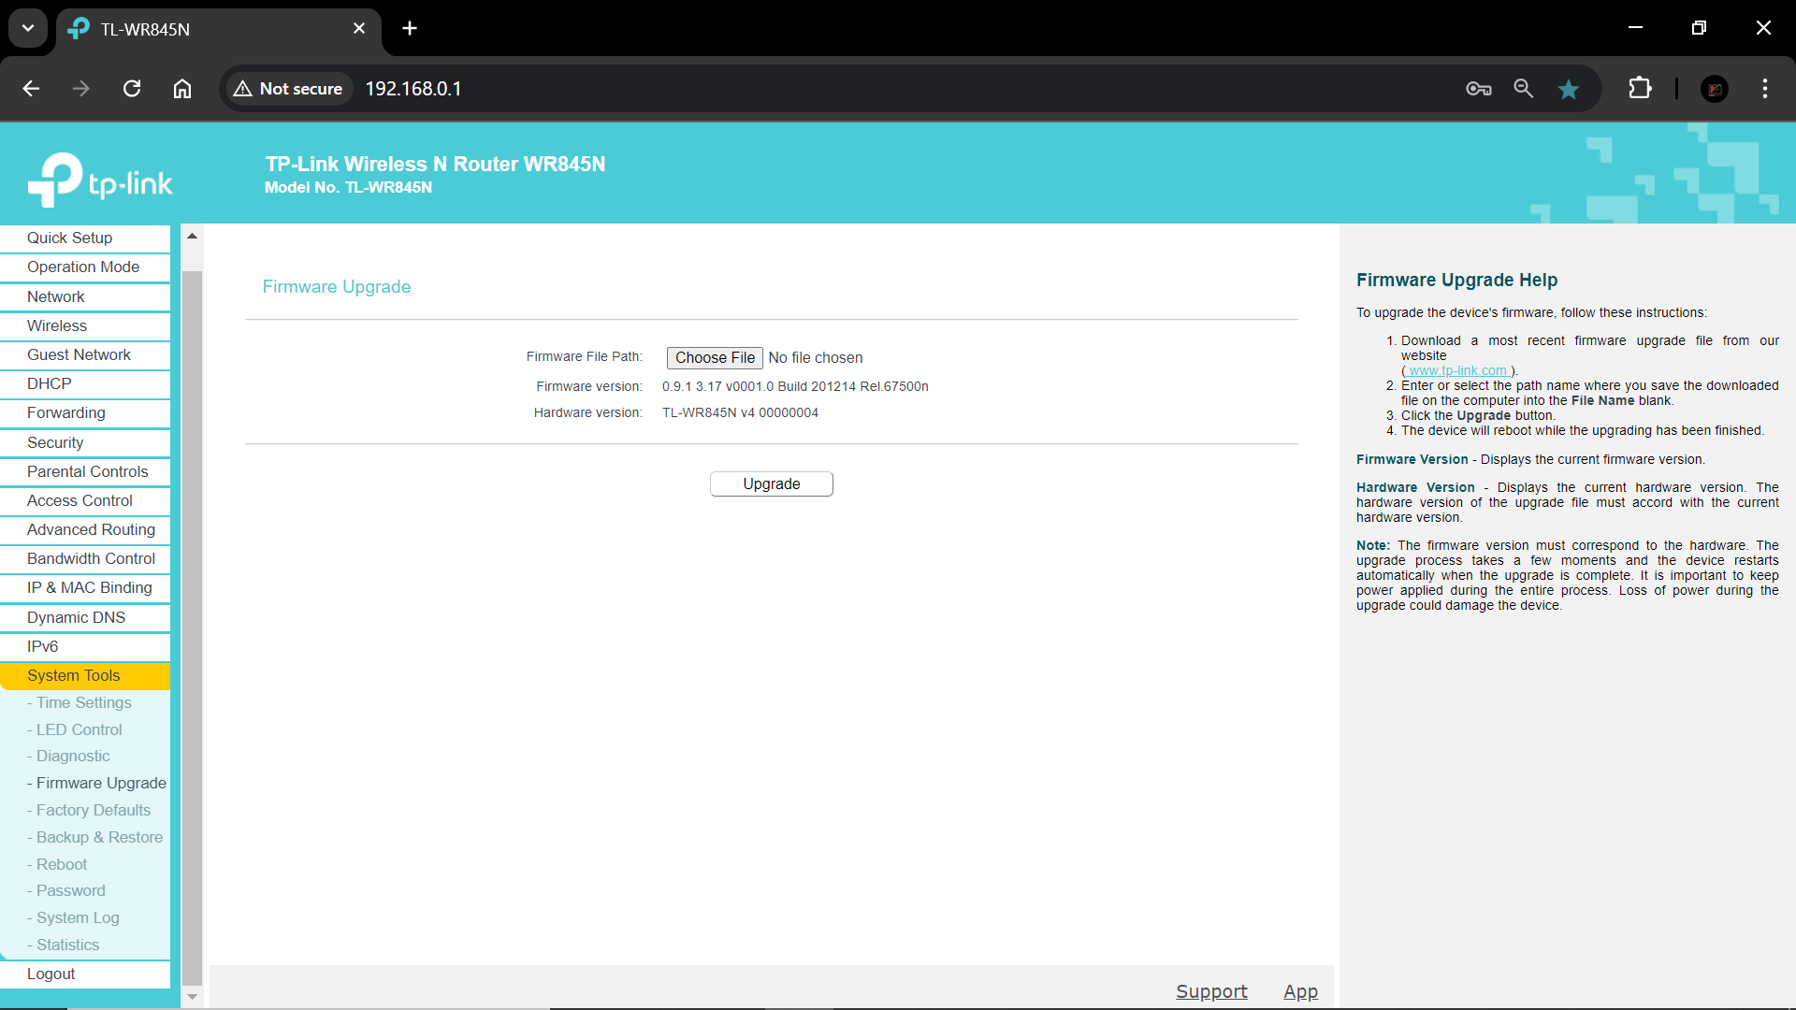

Step 8: Here I can check which devices are added to my Router’s network and also, I can check their IP address and MAC address along with their Device names and Lease time (It refers the amount of time a device uses an IP address before it needs to be renewed or replaced)

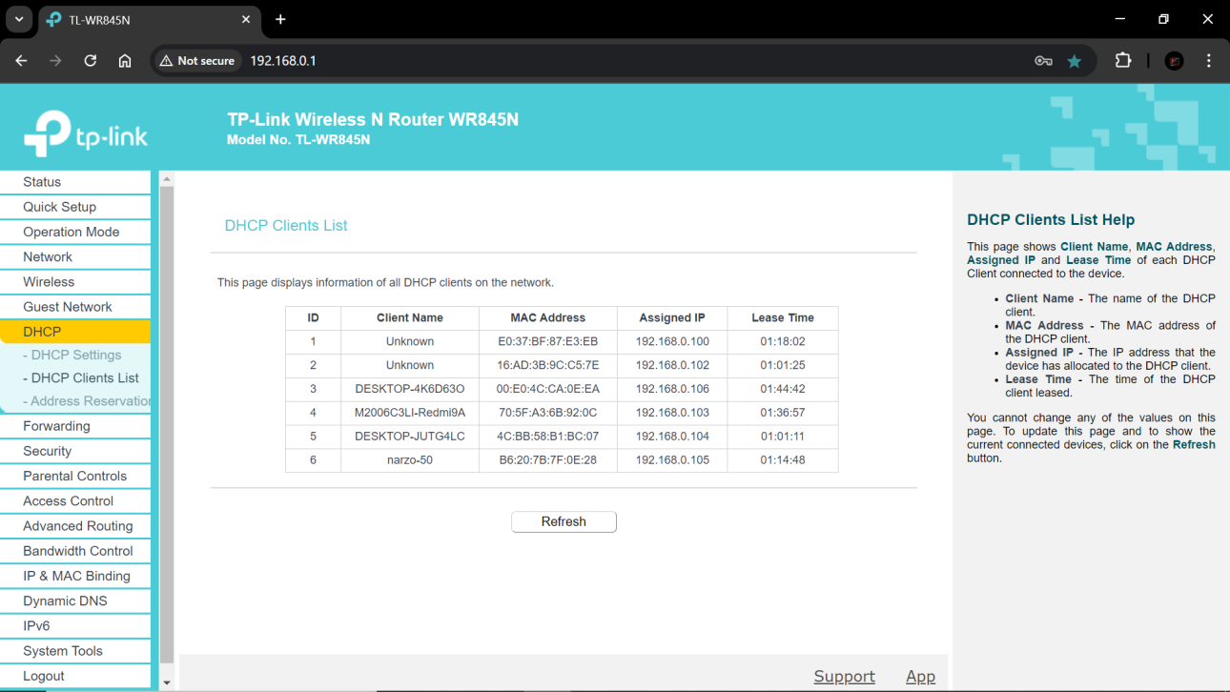

Step 9: Here I can manage ‘Parental controls’ that provide a restricted access to certain websites or limited internet usage during specific times of the day. I have to add the MAC addresses of the PCs where I want to have ‘parental control’

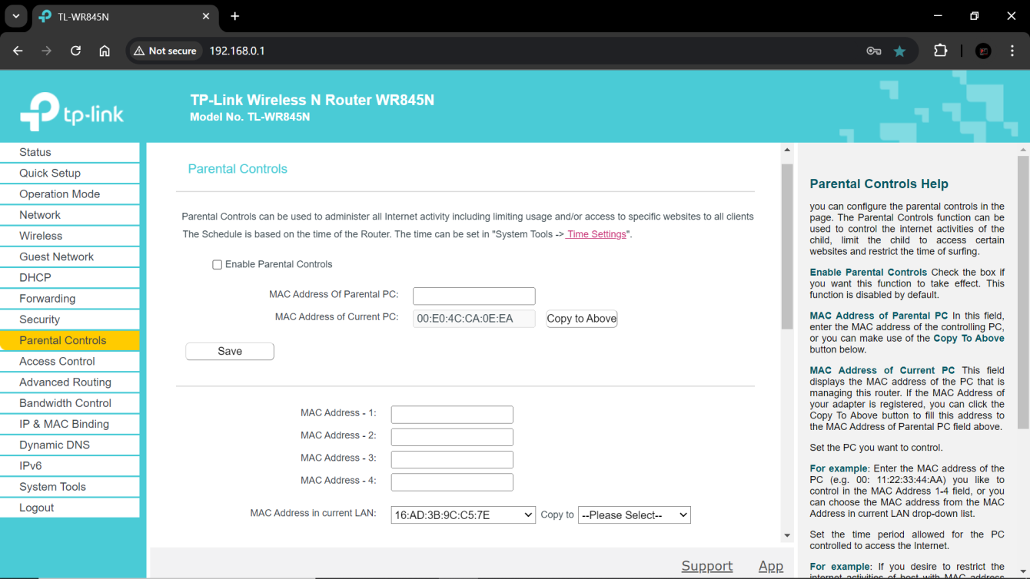

I have to set the schedule time and add the URL of the website which I want to restrict access. After change the setting I have to click on ‘save’

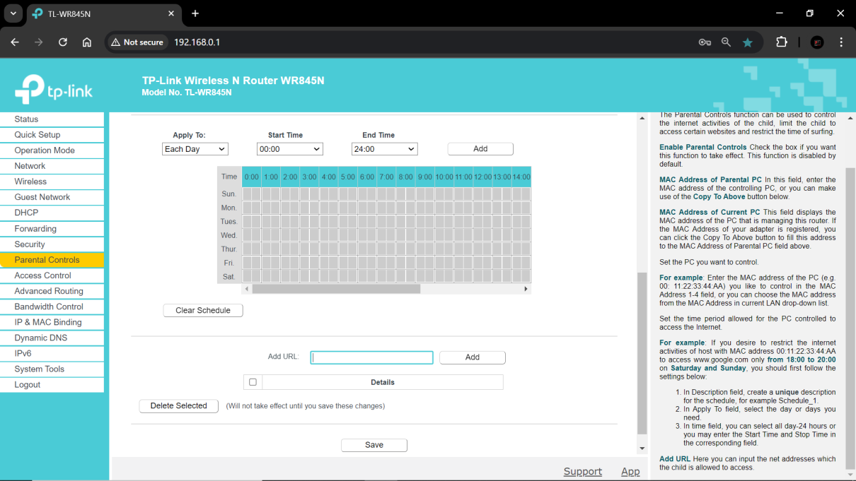

Step 10: Now after making changes to the setting of my Home Router, I have to save the settings and reboot the router, if necessary, to apply new configuration.

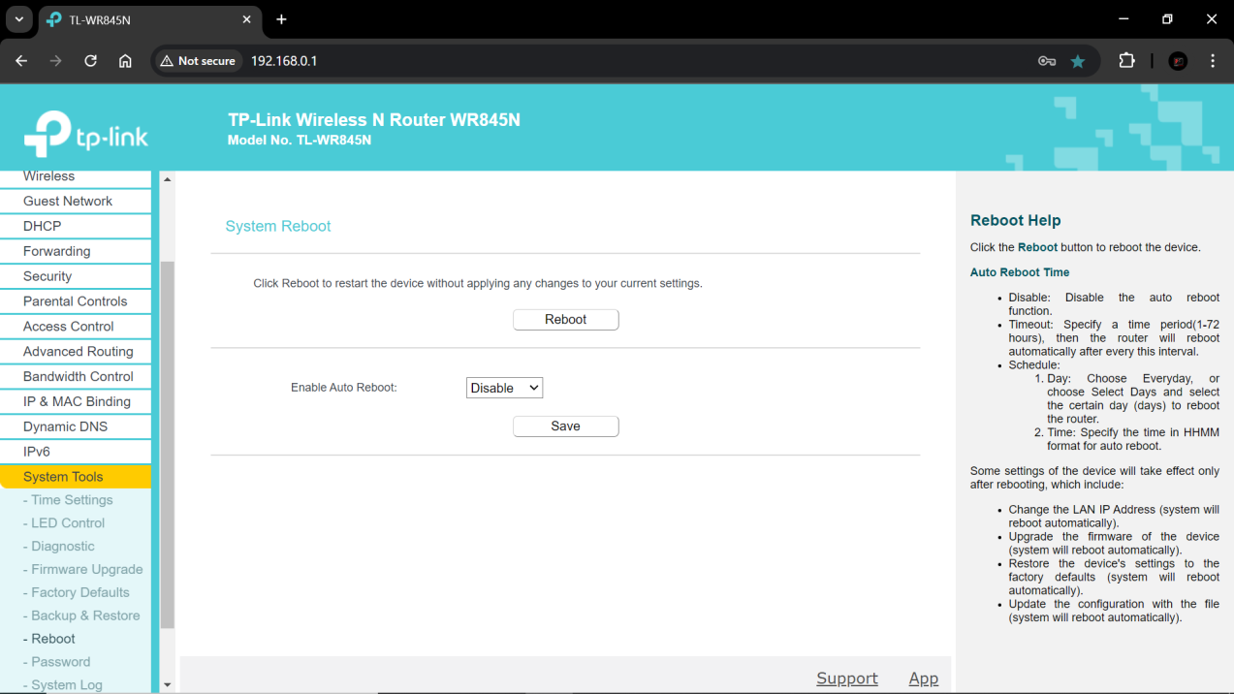

**Conclusion:**

By completing this project, I will have successfully configured some setting of my Router.

Router is a networking device that forwards data between computer networks.